Milestone II – Multi-agent Workflow
Agent Architecture Diagram (Sequential Pipeline Structure)
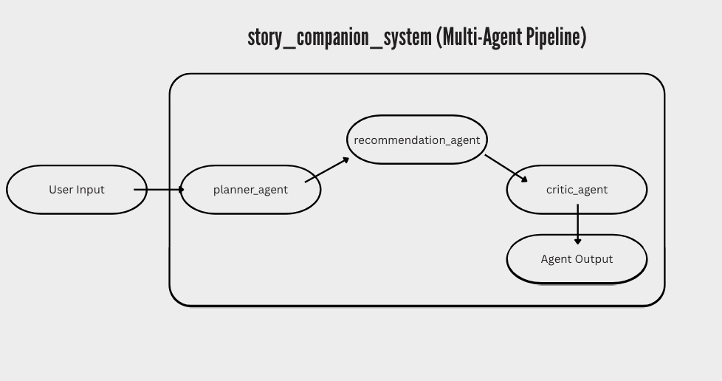
This system is a recommendation agent for users to find similarities between different media such as books, movies, or tv shows. To capture this, 3 different agents were implemented into the ai agentic system to develop a proper starting point for the multi-agent pipeline.
The first agent is the planner agent. This agent’s role is to break down the user’s request into a series of clear and unified tasks. The input is the user’s question which can be something simple like asking for a similar book title, or a more thorough request like the analysis of a piece. The output from this agent are structured steps that are needed to properly fulfill the request of the user. The main purpose of this agent is to guide the remaining agents to the correct output by categorizing and organizing the problem.
The second agent is the recommendation agent. This agent’s primary role is to generate a list of 3 – 5 book, movie, and/or show recommendations specifically based on the user’s preferences. This agent is using the user’s initial question along with the output of the planner agent. Once it has gone through the accurate recommendations, its output consist of a list of findings with explanations outlining their relevance to the user’s input. This agent executes the main functionality of the entire system.
The third and final agent is the critic agent. The main goal for the critic agent in this system is to review and refine the generated response from the user’s input and the recommendation agent’s output. It prioritizes a clean and polished version of the recommendations that it is in-line with the request of the user. The critic agent acts as an internal editor but does not reveal any changes or modifications to the user. The refining portion of the critic agent ensures that the final output seen by the user is quality, improves clarity, and most importantly, removes spoilers unless explicitly asked to be included by the user.
The agents communicate sequentially and require one agent to give a final output before the next agent uses the previous one’s output as an input, then begins its task. The planner agent processes the user’s input first. Then, the recommendation agent builds on top of that by using the output to go answer the question the user asked. Lastly, the critic agent refines the generated response which acts as the ‘cherry on top’ for the final output the user will see.
Some of the potential issues that may come up in this system include recommendations irrelevant to the user, a false inclusion of spoilers, or an unclear, ill-structured analysis. These issues are prevented or corrected using the critic agent. It reviews all the outputs and then revises the responses by removing all issues before the output ever reaches the user. This final agent makes sure to only allow accurate, relevant, and appropriate recommendations and descriptions that are aligned with the user’s expectations.
